Setting up mail on iPhone/iPad/iOS

Go Settings and move down to Mail, Contacts, Calendars -> Add Account

Tap Other -> Add Mail Account

Step 1  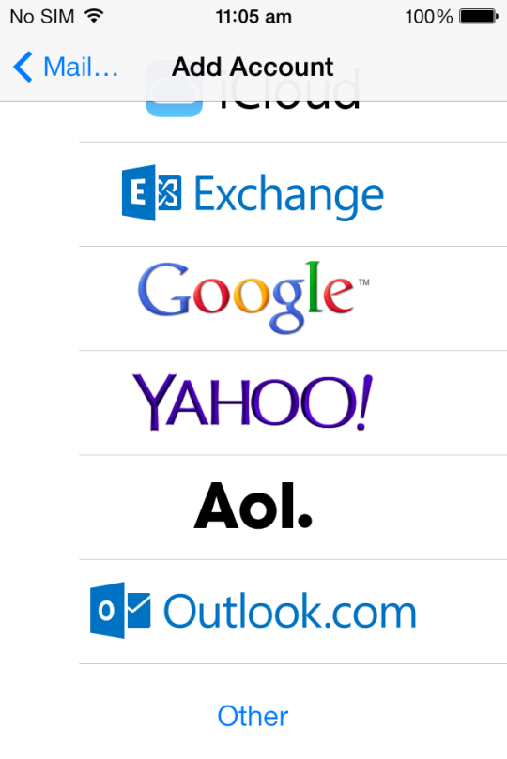 | Step 2  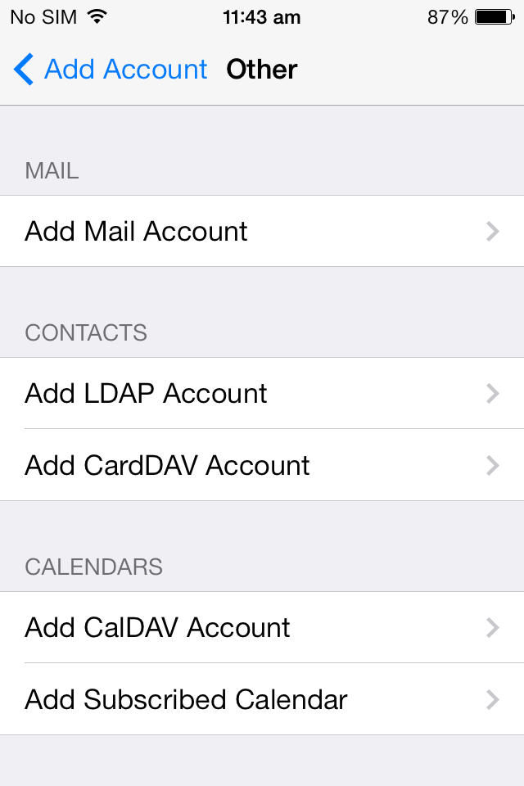
Step 3  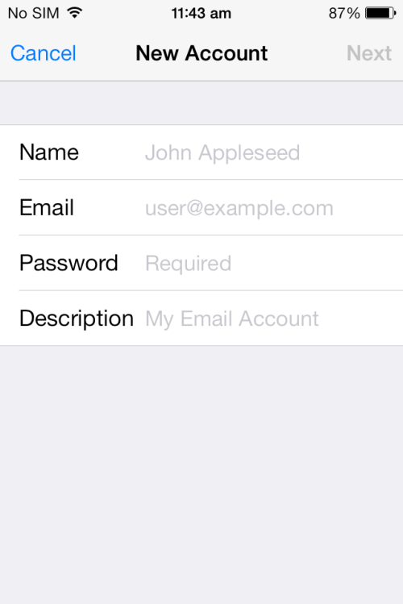  Fill out your details | Step 4 (i)  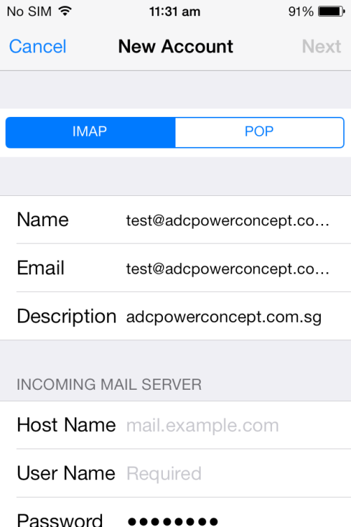
Step 4 (ii)  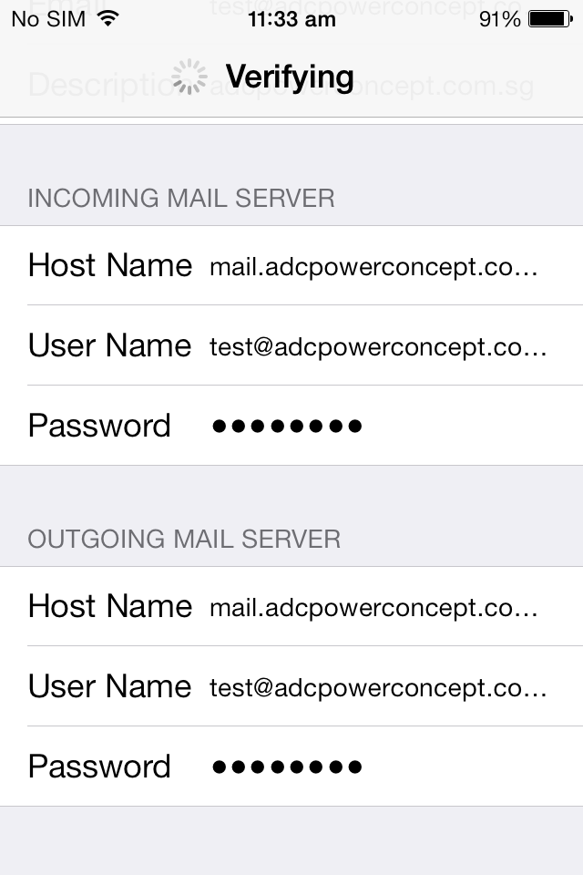  Host name can be:  pop.domain,  imap.domain,  mail.domain | Step 5  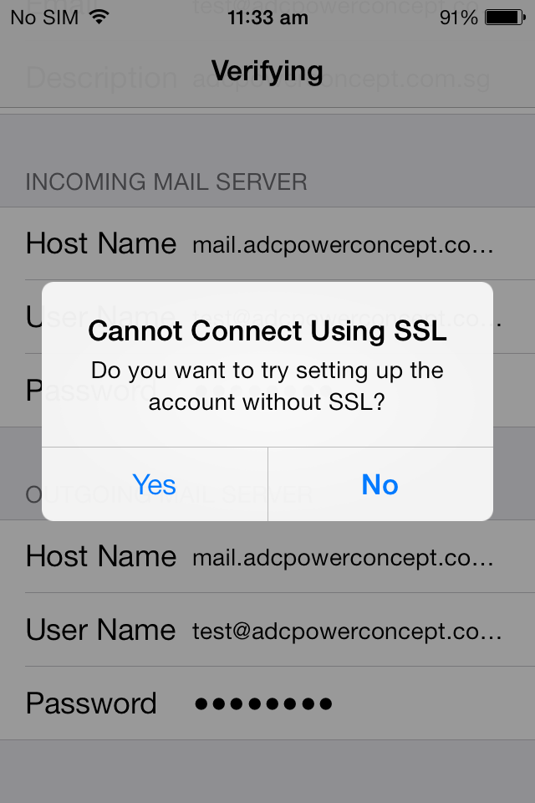  Choose Yes  It will auto verify the email for you.
Step 6  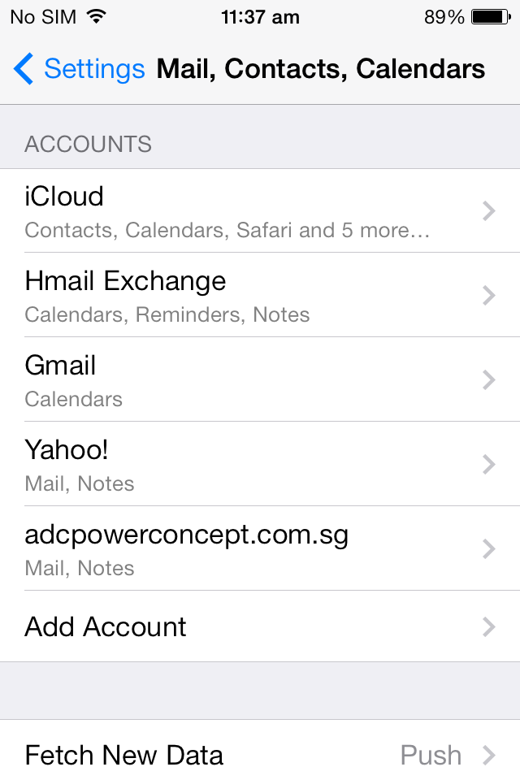  Tap the mail account you just created  Step 8  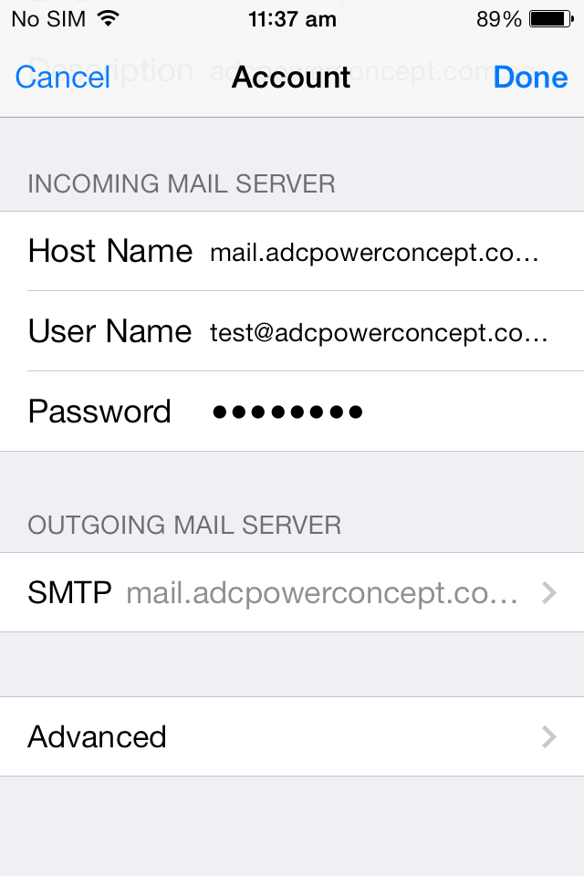  Tap SMTP to Step 9  Tap Advance to Step 10 | Step 7  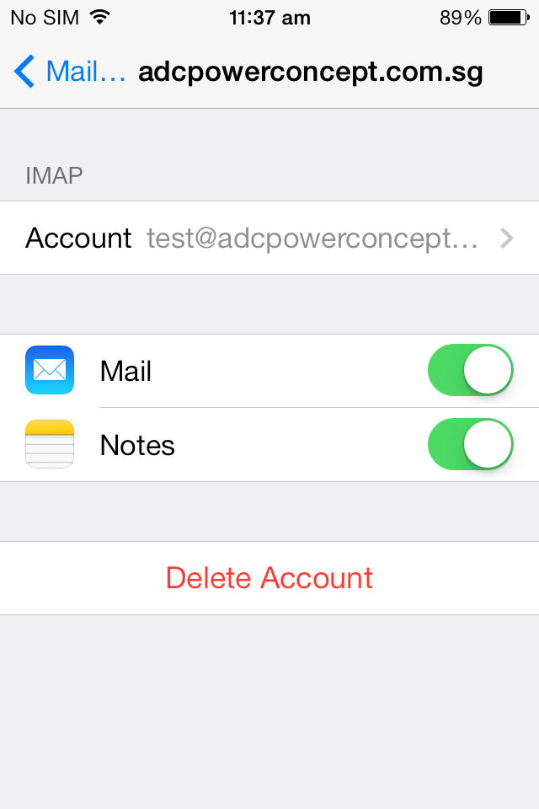  Tap the account  Step 9  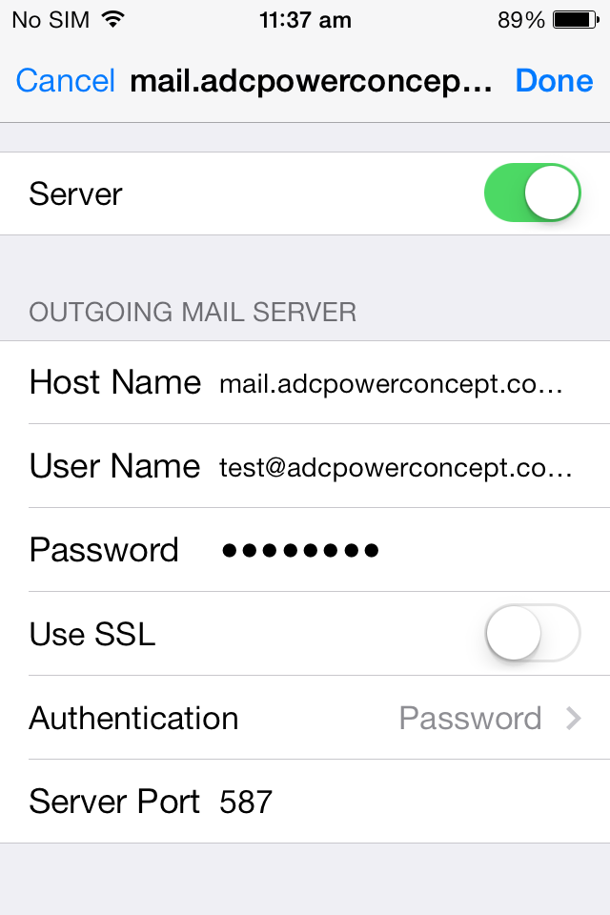  Set SSL OFF, Server Port 587  Authentication “Password” and then Done
Step 10
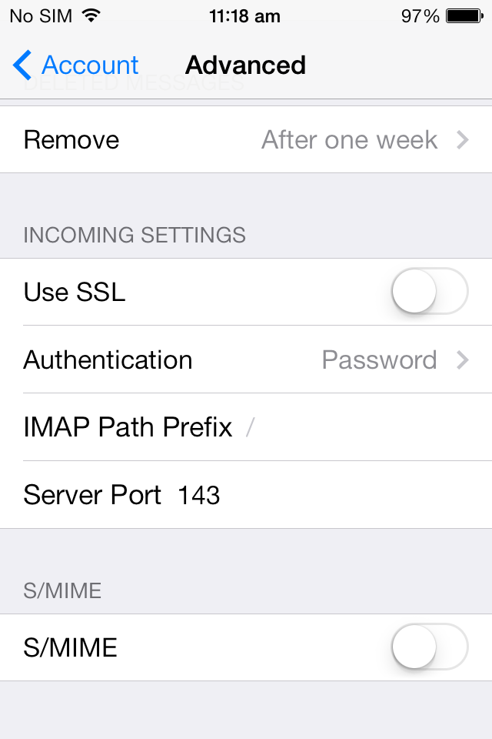 | - Set SSL OFF  - Set Server port to 143  - To verify the information, tap Done

