Setting up mail on Android Phone
Go Settings, under Applications Setting tap in to Email -> Manage Accounts -> Add Account (+)
Step 1  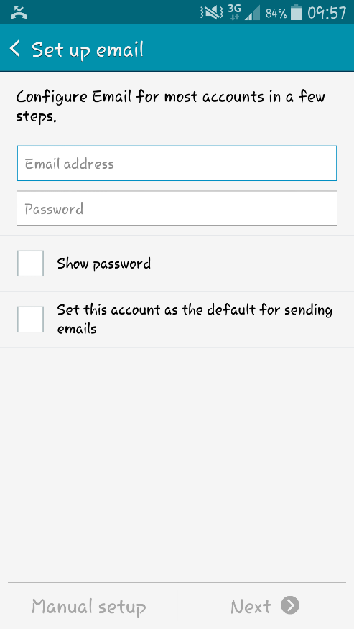  Enter Email and Password -> Choose Manual Setup | Step 2  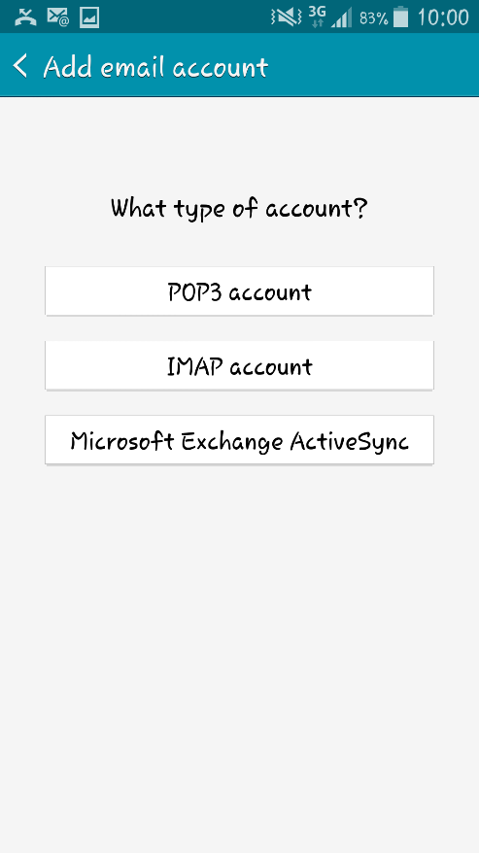  Choose IMAP account
Step 3  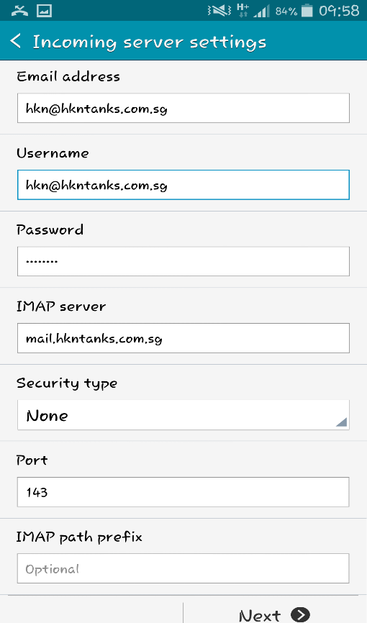 | Step 4  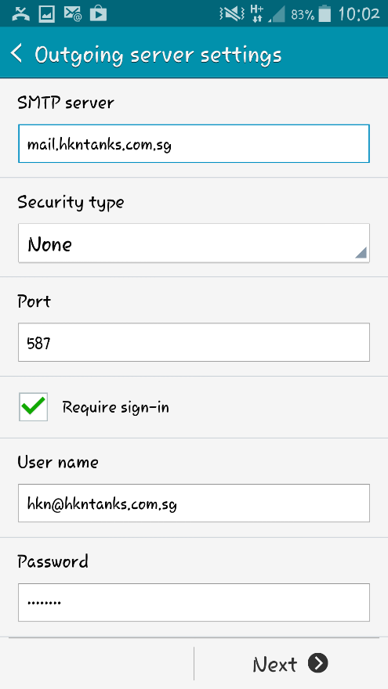
Step 5
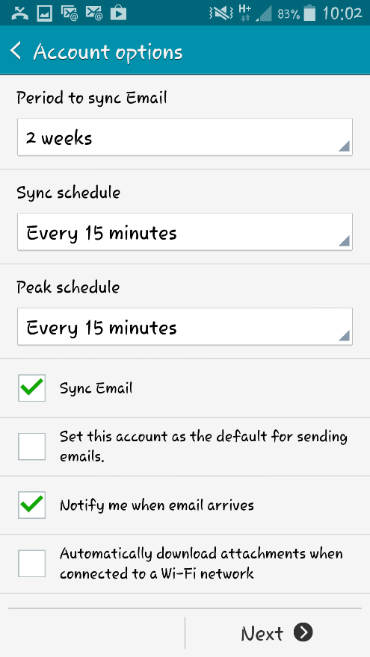
Click Next and you’re all done!

